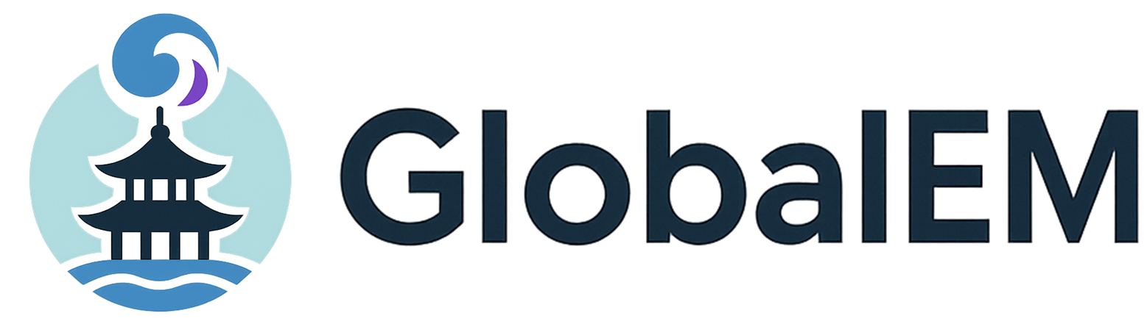 |  |  | 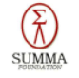

2026 Global Electromagnetics (GlobalEM 2026)

Proposals for Workshop/Tutorial Session

Proposal Types:
Please select the type of the proposal for further considerations. The deadline for Workshop and Tutorial Proposals is February 3, 2026.
- Workshop
- Tutorial

- Session Title:
XXXX

- Session Description (200 words):
The session description should address its category, objectives, contents, originality, and timeliness of the proposal, as well as the impact on the EMC community and beyond.
XXXX

- Expected Number of Speakers and Corresponding Topics
The expected number of speakers are: (Number)
- Author name, topic title
- Author name, topic title
- Author name, topic title

- Session Organizer(s) information
Session Organizer 1:
Name | Affiliation | Country | E-mail
Photo | Biography

Session Organizer 2:
Name | Affiliation | Country | E-mail
Photo | Biography

Session Organizer 3:
Name | Affiliation | Country | E-mail
Photo | Biography

- Any Other Information and Special Requests
Please indicate the special requirements or any other necessary information here. If no, please fill in “N.A”.
xxxx

------------------------------------------------------------------------------------------------------------------
Please submit your proposal(s) via email to the Symposium Workshop/Tutorial Chair:
Dr. Woo Sang Lee (wslee7@add.re.kr) and Prof. Eunmi Choi (emchoi@unist.ac.kr)

