GlobalEM 2026 Paper Title (Initial Letter of Each Word Capitalized)
Subtitle as needed
Author’s Name(s) per 1st Affiliation (Author)  line 1 (of Affiliation): dept. name of organization  line 2: Name of organization, acronyms acceptable  line 3: City, State (Province), Country  line 4: e-mail address if desired | Author’s Name(s) per 2nd Affiliation (Author)  line 1 (of Affiliation): dept. name of organization  line 2: Name of organization, acronyms acceptable  line 3: City, State (Province), Country  line 4: e-mail address if desired

This document gives instructions for preparing and submitting the 1-page extended abstract in Letter (215.9 mm × 279.4 mm) format to GlobalEM 2026, which will be held in Yonsei University, Seoul, South KOREA from June 29-July 3 2026. The document is to be prepared and submitted as a single PDF file via the OpenConf submission system through www.globalem2026.org. The paper, including figures and tables, must be written in English within one page. Please pick one of the Technical Committees under which your contribution will be most appropriate. Your paper will be reviewed as per the review process set up by GlobalEM 2026 organizers. If accepted it will be published in the Book of Abstracts available as an electronic copy. Authors are responsible for obtaining any required approvals for public release prior to submission. Please ensure your fonts are embedded and all mathematical symbols and equations are clearly seen while preparing your print ready PDF.
Abstract– (30–120 words) Summarize objective, approach, and key results. Do not include equations or tables.
Keywords– component, formatting, style, styling, insert (key words)

I. Introduction
This paper investigates system-level coupling and susceptibility under [HPM/NEMP/IEMI/UWB] excitation. A combined measurement-and-modeling approach is presented to quantify induced responses and evaluate mitigation strategies such as [shielding/filtering/grounding]. Experimental results demonstrate [key numerical/qualitative result], providing guidance for electromagnetic resilience in [platform/infrastructure]. ^{[1]-[3]}
High-power electromagnetic environments such as [NEMP/HPM/IEMI/lightning] can cause severe upset or damage in modern electronic systems. The objective of this study is to [objective]. The key contribution is [novelty], which improves [value/impact] compared with prior work.
II. Methodology
In this Section, briefly describe the methodology of your study. You may add the needed references [2], [3], or [2]-[5]. Footnotes are not recommended. Number equations consecutively with equation numbers in parentheses flush with the right margin, as in (1). Use either the Microsoft Equation Editor, or the MathType add-on (http://www.mathtype.com) to create the equations, e.g.,
(1)
where comma is used after the equation if variables are specified after this equation. Treat equations as parts of sentences with all the needed punctuation before and after the equations. Inserting a table with two unequal columns, one row, and no borders and shading for an equation is recommended. All variables in formulas must be identified (except for mathematical constants like e or π).
SI units are strongly encouraged, but CGS can be also used, if the proper conversion is shown. English units may be used as secondary units (in parentheses).
There are some common mistakes that must be avoided, see Write Your Paper and guidelines in the templates. Figures should be mentioned in the text are referred, e.g., as Fig. 1, exactly as in the caption to the figure.
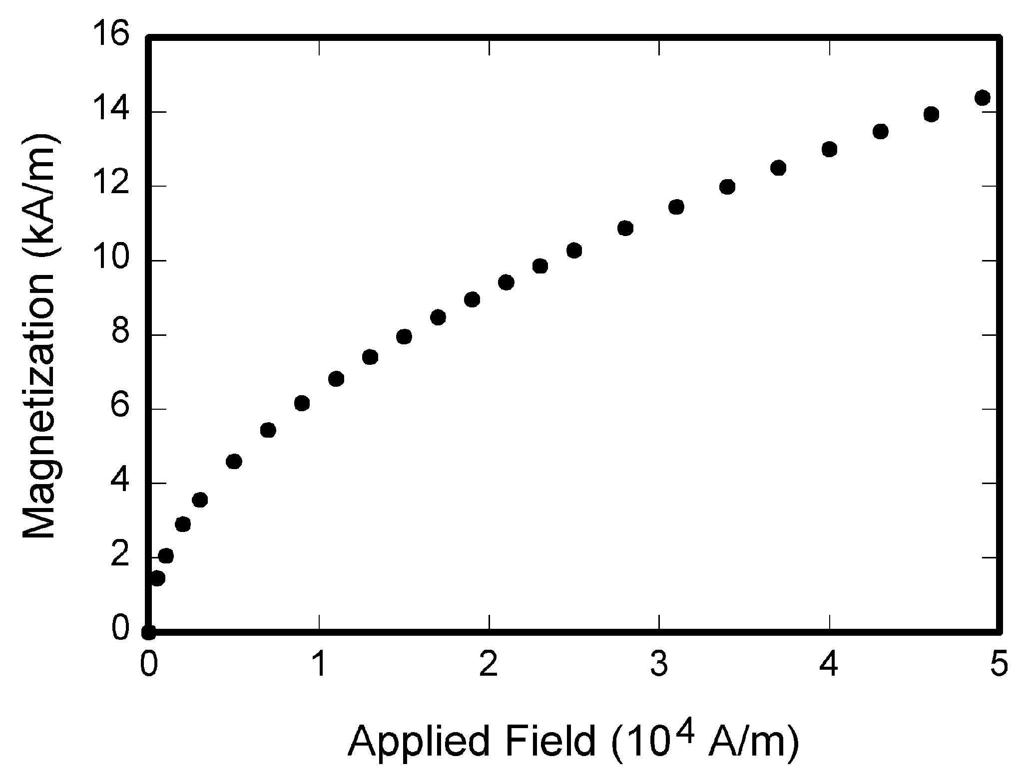
Fig. 1. Note that “Fig.” is abbreviated. There is a period after the figure number, followed by two spaces. Fonts should be readable, lines easy to distinguish.
III. Results and Discussion
Provide brief description of results of this work. The results can be illustrated by figures, e.g., as is shown in Fig. 1. Figures can be colored, but a reader should be able to distinguish lines when printed in black-and-white. Use different line styles, line thicknesses, and colors, and the proper labeling of lines to make your figures clear and readable. If you use tables, they should be numbered with Roman numerals, e.g., as Table I.

- Table Type Styles
Table Head | Table Column Head
Table Head | Table column subhead | Subhead | Subhead
# | More table contents | aaa | bbb
IV. Conclusion
Measured and simulated results show that [main result]. The proposed mitigation reduces [metric] by [value], enabling improved resilience against [HPEM type]. These findings support design guidelines for [application].
Acknowledgment
This work was supported by the [Funding Agency/Program] under Grant [Grant Number]. The authors also thank [Lab/Institute/Project Team] for their technical support and helpful discussions.
References
- F. A. Author, “Title of paper,” Journal/Conference, vol. x, no. y, pp. xx–yy, year.
- S. B. Author, “Title of book,” Publisher, year.
- H. W. Ott, Electromagnetic Compatibility Engineering, 1st Ed., John Wiley & Sons, Inc, 2009
- C.R. Paul, Introduction to Electromagnetic Compatibility, 2nd Ed., John Wiley & Sons, Inc, 2006
- Laird, www.laird.com

